**Database and Management System Lab**

NAME: PRIYANSHI VARSHNEY

ROLL NO: R2142230042

SAP_ID: 500119947

BATCH 2

B.TECH CSE, SEM-III

**EXPERIMENT 9**

**Title: To understand the concepts of Views.**

**Objective:** Students will be able to implement the concept of views

**1. Create table of table name: EMPLOYEES and add 6 rows**

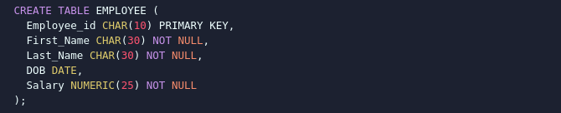

**2. Create a View emp_view with Specific Columns**



**3. Insert Values into the View (emp_view)**



**4. Modify, delete and drop operations are performed on view**







**5. Creates a view named salary_view. The view shows the employees in department 20 and their annual salary**

